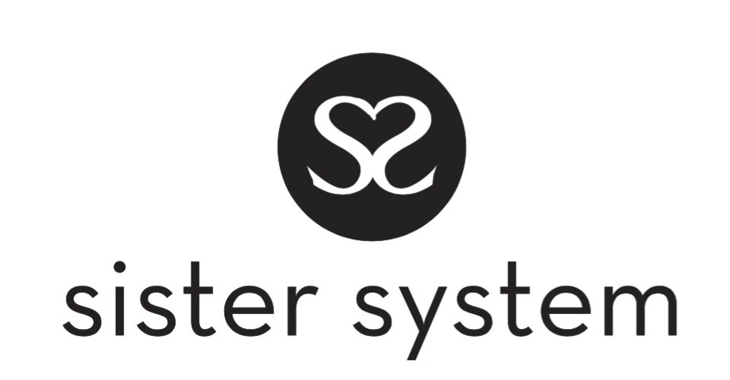

Sister System
Studio 26, The Trampery, 639 High Road, London, N17 8AA
Email: programmes@sistersystem.org
Telephone: +44 07763 008018 Web: www.sistersystem.org

Self-Referral Form-Sister System

Name: -----------------------------------------------------------------------------------------

Date Of Birth: -----------------------------------------------------------

Address: -----------------------------------------------------------------

-------------------------------------------------------------------

-------------------------------------------------------------------

--------------------------------------------------------------------

Who do you live with?

On own/independently: yes/no (please tick/mark the appropriate box-) In flat

In bedsit

In semi independence unit

Live with foster parents: yes/no

Live with birth parent: yes/no

Would you like to provide an emergency contact: yes/no

If ‘yes’ who they are to you:....................................

Contact phone number for your contact: --------------------------------------

Are you a survivor of:

child Sexual Exploitation domestic violence rape

control or coercion child sexual abuse physical abuse

Have you ever experienced?

depression anxiety bipolar extreme Stress hypermania

loneliness anger bereavement panic attacks sleeplessness

Anything else please note? ………………………………………………………………………………...
(If you would like to speak with us about any of the above, that's also fine).

Do you think you have challenges with drugs or alcohol? yes/no (please indicate)
If ‘yes’ which drugs please specify: …………………………………………………………..

Hobbies & Interest if any please share with us? ----------------------------------------------------------------------------------------------------

------------------------------------------------------------------------------------------------

---------------------------------------------------------------------------------------------------

-------------------------------------------------------------------------------------------------

What support do you think you would need from the Sister System? (If you are unsure at this stage don’t worry we can discuss this).

---------------------------------------------------------------------------------------------------------------------------------------------------

-------------------------------------------------------------------------------------------------------------------------------------------------

------------------------------------------------------------------------------------------------------------------------------------------------

----------------------------------------------------------------------------------------------------------------------------------------------

What programme interests you (please refer to website for info)?

---------------------------------------------------------------------------------------------------------------------------------------------

---------------------------------------------------------------------------------------------------------------------------------------------

--------------------------------------------------------------------------------------------------------------------------------------------

Tell us how the care system affected you?

------------------------------------------------------------------------------------------------------------------------------------------------------

------------------------------------------------------------------------------------------------------------------------------------------------------------

------------------------------------------------------------------------------------------------------------------------------------------------------------

------------------------------------------------------------------------------------------------------------------------------------------------------------

Who is currently supporting you professionally or otherwise?

---------------------------------------------------------------------------------------------------------------------------------------------

--------------------------------------------------------------------------------------------------------------------------------------------

--------------------------------------------------------------------------------------------------------------------------------------------

-------------------------------------------------------------------------------------------------------------------------------------------

Are you currently-(please mark)

In school In college At university

Not in education or training Not working
Thank you for completing this self-referral form, please email it to programmes@sistersystem.org or alternatively post it to our offices, address at the top of this form.

Next Steps- On receipt of this referral please expect a phone call within 5 days/unless urgent from one of our Sisters, who will arrange to speak with you which can either be done remotely or social distancing face-face.

